LABORATORIO ARTIGIANO RETI
di ARCHETTI CARLO
Reti da Pesca – Sport – Caccia
Recinzione Impianti Sportivi
Antinfortunistica – Acquacoltura
25058 SULZANO (BS) – Via Tassano, n. 8
Tel. e Fax 030/985290 – Tel. Ab. 030/985191
Cell. 328 0562071 c.f. RCHCRL64C01F532U – P.I. 03216410179
www.retiarchetti.it – info@retiarchetti.it
www.retiarchetti.com – info@retiarchetti.com
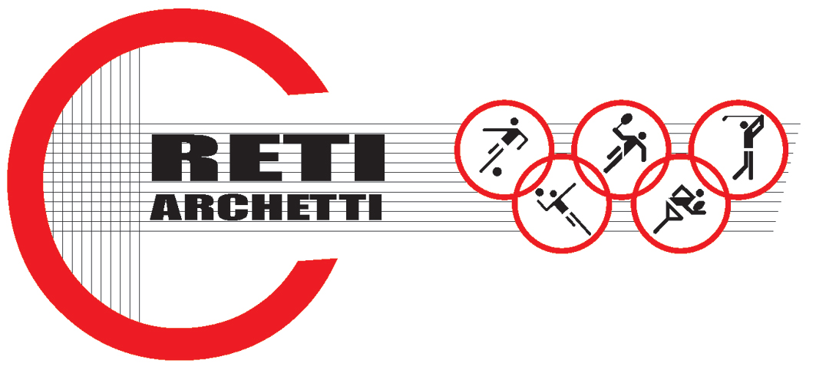

TECHNICAL DATA SHEET ART.CODE: AN 3

NET MADE OF HIGH RESISTANT NYLON, MESH mm 42 x 42, THICKNESS mm 3

BREAKING TEST: tests carried out on a nylon net, without knot, white colored (title 210/90 braid Ø mm 3 and mesh mm 42) according to Standard EN 1263-1.
Equipment used for the test on a sample with 5 meshes: dynamometer “Acquati model AG 5” with a max. carrying capacity of 5000 kg.

ELONGATION: 50%
ULTIMATE STRENGTH: 290 daN

Technical features

- MATERIAL: Nylon polyamide 6, title 210/90, without knot.
- AVAILABLE COLORS: white
- YARN THICKNESS: 3 mm.
- NET: squared mesh
- MESH: mm. 42 x 42
- WEIGHT: g. 215/Sq m
- EDGE STRIP: with a 8 mm high resistant nylon braid.

Each net can be manufactured with length and width on customer request. Nets are complete with a double reinforced strip along the edge with a 8 mm braid sewed to the net. A piece of rope at the angles makes the installation easier.

